**Q1. Write a JSP that reads parameters from user login page.**

**index.html**

<!DOCTYPE html>

<html>

<head>

<title>Login Page</title>

</head>

<body>

<h1 align=center>Login</h1>

<form name="form1" action="loginJsp.jsp" method="post">

<table>

<tr>

<td><b>UserName:</td>

<td><input type=txt name=t1></td>

</tr>

<tr>

<td><b>Password:</td>

<td><input type=password name=t2></td>

</tr>

<tr>

<td><input type=submit value=submit></td>

<td><input type=reset value=cancel></td>

</tr>

</table>

</form>

</body>

</html>

<%@ page language=*"java"* contentType=*"text/html; charset=ISO-8859-1"*

pageEncoding=*"ISO-8859-1"*%>

<!DOCTYPE html>

<%@ page import=*"java.io.*"*%>

<%@ page import=*"javax.servlet.*"*%>

<%@ page import=*"javax.servlet.http.*"*%>

<%@ page import=*"javax.servlet.jsp.*"*%>

<html>

<head>

<title>Login</title>

</head>

<body>

<%out.println("User Name is:"+request.getParameter("t1"));

%>

<br/>

<%

out.println("Password is:"+request.getParameter("t2"));

%>

</body>

</html>

**loginJsp.jsp**

<%@ page language=*"java"* contentType=*"text/html; charset=ISO-8859-1"*

pageEncoding=*"ISO-8859-1"*%>

<!DOCTYPE html>

<%@ page import=*"java.io.*"*%>

<%@ page import=*"javax.servlet.*"*%>

<%@ page import=*"javax.servlet.http.*"*%>

<%@ page import=*"javax.servlet.jsp.*"*%>

<html>

<head>

<title>Login</title>

</head>

<body>

<%out.println("User Name is:"+request.getParameter("t1"));

%>

<br/>

<%

out.println("Password is:"+request.getParameter("t2"));

%>

</body>

</html>

**Output:**

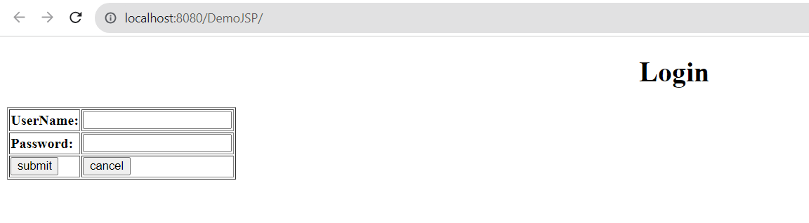

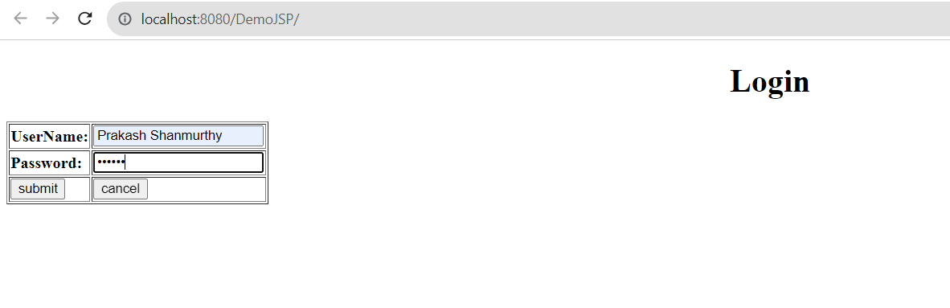

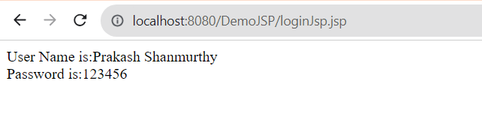

**Q2. Implement the java server page to print factorial value of any integer number, while the input has to be taken from an HTML form.**

**index.html**

<!DOCTYPE html>

<html>

<head>

<meta charset="ISO-8859-1">

<title>Factorial Computation</title>

</head>

<body>

<form action="Factorial.jsp">

<h1>Enter the no:<input type="text" name="n"/></h1>

<input type="Submit" value="Submit">

</form>

</body>

</html>

**Factorial.jsp**

<%@ page language=*"java"* contentType=*"text/html; charset=ISO-8859-1"*

pageEncoding=*"ISO-8859-1"*%>

<!DOCTYPE html>

<html>

<head>

<meta charset=*"ISO-8859-1"*>

<title>Insert title here</title>

</head>

<body>

<h1>The Factorial value is:</h1>

<h2>

<%

**int** n,i;

**int** fact=1;

String ns=request.getParameter("n");

n=Integer.parseInt(ns);

**for**(i=1;i<=n;i++)

fact=fact*i;

out.println("Factorial="+fact);

%>

</h2>

</body>

</html>

**Output:**

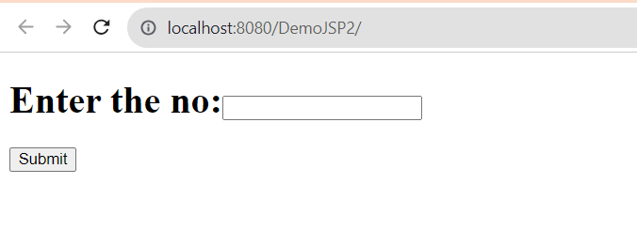

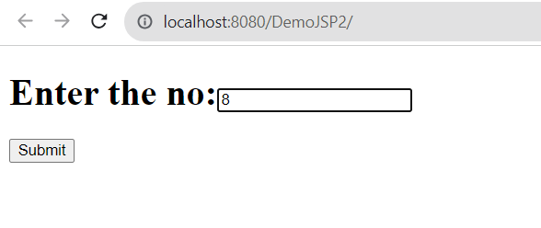

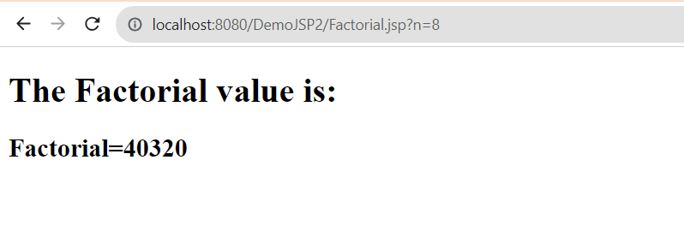

**3. Implement java server page to insert the Employee details into the database over web and fetch those details using one more JSP page.**

1. Initially the request will go from index.jsp page to Register Servlet page, then if any of the field will be blank means->it will move to error.jsp,otherwise it will move to Register.jsp.

2. Copy all the jar files into the lib folder and import the jar files via java build path too.

3.Run index.jsp page.

**Database Creation:**

SHOW DATABASES;

CREATE DATABASE userinfo;

USE userinfo;

CREATE TABLE employee(username varchar(100) PRIMARY KEY,

pass varchar(50),

address varchar(200));

DESC employee;

**index.jsp**

<%@ page language=*"java"* contentType=*"text/html; charset=ISO-8859-1"*

pageEncoding=*"ISO-8859-1"*%>

<!DOCTYPE html>

<html>

<head>

<meta charset=*"ISO-8859-1"*>

<title>Insert title here</title>

</head>

<body>

<h2>Registration Form</h2>

<form action=*"RegisterServ"* method=*"post"*>

<table style="width: *50%*">

<tr>

<td>UserName</td>

<td><input type=*"text"* name=*"username"* /></td>

</tr>

<tr>

<td>Password</td>

<td><input type=*"password"* name=*"password"* /></td>

</tr>

<tr>

<td>Address</td>

<td><input type=*"text"* name=*"address"* /></td>

</tr>

</table>

<input type=*"submit"* value=*"Submit"* /></form>

</body>

</html>

**RegisterServ.java**

package myservelats;

import java.io.IOException;

import java.io.PrintWriter;

import java.sql.Connection;

import java.sql.DriverManager;

import java.sql.PreparedStatement;

import java.sql.SQLException;

import javax.servlet.RequestDispatcher;

import javax.servlet.ServletException;

import javax.servlet.annotation.WebServlet;

import javax.servlet.http.HttpServlet;

import javax.servlet.http.HttpServletRequest;

import javax.servlet.http.HttpServletResponse;

/**

* Servlet implementation class RegisterServ

*/

@WebServlet("/RegisterServ")

public class RegisterServ extends HttpServlet {

private static final long serialVersionUID = 1L;

protected void doPost(HttpServletRequest request, HttpServletResponse response) throws ServletException, IOException {

PrintWriter out = response.getWriter();

String username = request.getParameter("username");

String pass = request.getParameter("password");

String address = request.getParameter("address");

try {

Class.forName("com.mysql.jdbc.Driver");

} catch (ClassNotFoundException e) {

// TODO Auto-generated catch block

e.printStackTrace();

}

//creating connection with the database

try {

Connection con;

con = DriverManager.getConnection ("jdbc:mysql://localhost:3306/userinfo","root","root");

PreparedStatement ps=con.prepareStatement("insert into employee values(?,?,?)");

ps.setString(1, username);

ps.setString(2,pass);

ps.setString(3,address);

int i=ps.executeUpdate();

if(username.isEmpty() || pass.isEmpty() || address.isEmpty())

{

RequestDispatcher req = request.getRequestDispatcher("error.jsp");

req.include(request, response);

}

else

{

out.println("You are sucessfully registered");

RequestDispatcher req = request.getRequestDispatcher("Register.jsp");

req.forward(request, response);

}

} catch (SQLException e) {

// TODO Auto-generated catch block

e.printStackTrace();

}

}

}

**error.jsp**

<%@ page language=*"java"* contentType=*"text/html; charset=ISO-8859-1"*

pageEncoding=*"ISO-8859-1"*%>

<!DOCTYPE html>

<html>

<head>

<meta charset=*"ISO-8859-1"*>

<title>Employee Registration</title>

</head>

<body>

<h2>You have not completed the details</h2>

</body>

</html>

**Register.jsp**

<%@ page language=*"java"* contentType=*"text/html; charset=ISO-8859-1"*

pageEncoding=*"ISO-8859-1"*%>

<%@page import=*"java.sql.*"*%>

<!DOCTYPE html>

<html>

<head>

<meta charset=*"ISO-8859-1"*>

<title>Insert title here</title>

</head>

<body>

<a><b>Welcome User!!!!</b></a>

<%

**try**{

Connection con= DriverManager.getConnection("jdbc:mysql://localhost:3306/userinfo","root","root");

Statement st = con.createStatement();

ResultSet rs = st.executeQuery("select *from employee");

out.println("<html><head><title>employee</title></head>");

out.println("<body bgcolor=orange><center>");

out.println("<table border=2>");

out.println("<tr><td>Username</td><td>Password</td><td>Address</td></tr>");

**while**(rs.next())

{

out.println("<tr><td>"+rs.getString(1)+"</td>");

out.println("<td>"+rs.getString(2)+"</td>");

out.println("<td>"+rs.getString(3)+"</td></tr>");

}

out.println("</center></table></body></html>");

}

**catch**(Exception se)

{

se.printStackTrace();

} %>

</body>

</html>

**Output:**

